**ULTRASONIC SENSOR DETECTION AND PREENTION OF ROAD ACCIDENT BY USING OF ARDUINO UNO**

*A PROJECT REPORT*

*Submitted by*

YANUMALA KARTHIK REDDY - 123006086

P V G NAVYATHA REDDY - 123004136

ARIKATLA SREE TEJA SANNIDHYA - 123004028

*towards partial fulfilment of the requirements for the award of the degree*

*of*

Bachelor of Technology

in

Electronics and Communication Engineering

And

Electronics and Instrumentation Engineering



**School of Electrical and Electronics Engineering**

**SASTRA DEEMED TO BE UNIVERSITY**

(A University established under section 3 of the UGC Act, 1956)

Thirumalaisamudiram

Thanjavur-613 401

**JAN 2022**

**BONAFIDE CERTIFICATE**

This is to certify that the report titled **“Ultrasonic sensor detection and prevention of road accident by using of Arduino UNO ”** is a bonafide record of the work carried out by

Yanumala Karthik Reddy- 123006086

P V G Navyatha Reddy - 123004163

Arikatla Sree Teja Sannidhya - 123004028

student of B.Tech., Electronics and Communication Engineering & Electronics and Instrumentation Engineering, in partial fulfilment of the requirement for the award of the degree of B.Tech in Electronics and Communication Engineering of the **SASTRA DEEMED TO BE UNIVERSITY, Thirumalaisamudram, Thanjavur – 613401,** during the year 2021-2022.

**NAME OF THE INTERNAL GUIDE:** Dr N Mohan Raj, SEEE SASTRA

**SIGNATURE**

Project Viva voce held on 

**Examiner1 Examiner2**

**ACKNOWLEDGEMENT**

The contentment and elation that accompany the successful completion of any work would be incomplete without mentioning the people who made it possible.

Words are inadequate in offering our sincere thanks and gratitude to our respected Vice-Chancellor Dr.S.Vaidhyasubramanian for providing us with various facilities and opportunities to enlighten our knowledge for a better future.

I record my sincere thanks to Dr R.Chandramouli, Registrar for his kind consideration and encouragement during my educational pursuit.

I express my sincere gratitude to our beloved eminent Dean Dr.K.Thenmozhi for support and encouragement.

I sincerely thank Dr.K.Sridhar, Associate Dean for having extended helping hands at all times.

I also express my most heartfelt sense of gratitude to Prof.Raju N, SAP for the help in arranging all the administrative procedures and providing all the facilities for the successful completion of the summer project.

It is with a deep sense of gratitude that I acknowledge my indebtedness to my Project Supervisor, Dr N Mohan Raj, for his consistent support and encouragement. It was he who provided an aim and direction to this project and constantly pushed me to work harder on it.

I must express my gratitude to my parents for being with me every moment and providing continuous morale-boosting and affection.

Finally, I thank Almighty for having kept me in peace and good health which paved the way for the successful completion of my project

**ABSTRACT**

**KEYWORDS:**Arduino Uno , UV Sensors ,Hair Pin Bend Road.

Modern vehicles frequently come equipped with a collision mitigation system, also referred to as a pre-crash system, to lessen collisions. However, the majority of vehicles on the road, particularly large motor vehicles, lack such a mechanism.

The primary goal of a collision avoidance system is to lessen the risks of collisions at hairpin bends in curving highways, on mountainous terrain, on ghat roads, or at other blind curves. A selection of ultrasonic sensors, LEDs, etc. are included in the suggested system. On either side of the hairpin bend are UV sensors that are used. The sensors, which are wired to the LEDs and mutually exclusive, cannot be used together. The LEDs will illuminate and begin to alert the other car approaching from the opposite end of the bend based on the position of the vehicle. Drivers will therefore slow down, which will aid in preventing collisions. The LEDs will make it easier for the drivers of the cars on either side of the bend to see whether any cars are approaching from the opposite direction. The system avoids a potential accident at the curve when there are weather conditions that decrease the visibility of the convex lens, such as heavy fog or snow.

**TABLE OF CONTENTS**

**TITLE PAGE NO**

ACKNOWLEDGEMENTS iii

ABSTRACT iv

LIST OF FIGURES vii

LIST OF TABLES viii

ABBREVIATIONS ix

**1.** **INTRODUCTION**

* 1. Road Traffic Accident 1
  2. Reasons for RTA 2
  3. Preventive measures 3
  4. Internet of Things 4

**2. OBJECTIVES** 5

**3. METHODOLOGY**

* 1. Working 6
  2. Implementation of Circuit 7
  3. Implementation of Code and Testing 11

**4. RESULTS AND DISCUSSION 12**

**5. CONCLUSION AND FURTHER WORK 14** **6. REFERENCES**   **15**

**LIST OF FIGURES**

|  |  |  |
| --- | --- | --- |
| **FIGURE NO** | **TITLE** | **PAGE NO.** |
| 1.1 | Road Traffic Accident | 10 |
| 3.1 | Block Diagram Of Proposed System | 15 |
| 3.2.1 | Arduino Uno | 16 |
| 3.2.2 | Ultrasonic Sensor | 17 |
| 3.2.3 | RED LED | 17 |
| 3.2.4 | Buzzer | 18 |
| 3.2.5 | Circuit Diagram | 18 |
| 4.1 | Implementation of Circuit Case i | 21 |
| 4.2 | Implementation of Circuit Case ii | 22 |

**LIST OF TABLES**

|  |  |  |
| --- | --- | --- |
| **TABLE NO.** | **TITLE** | **PAGE NO.** |
| 3.2.1 | Specifications of Arduino Uno | 16 |
| 3.2.2 | Specifications of Ultrasonic Sensor | 17 |
| 3.2.3 | Specifications of RED LED | 17 |
| 3.2.4 | Specifications of Buzzer | 18 |
| 4.1 | Outcomes of Experiment | 22 |

**ABBREVIATIONS**

LCD Liquid Crystal Display

UV Ultra Violet

LED Light Emitting Diode

RTA Road Traffic Accident

**CHAPTER 1**

**INTRODUCTION**

* 1. **Road Traffic Accidents**

Over a million people worldwide lose their lives in traffic accidents. It is one of the top causes of death, according to the World Health Organization (WHO). Many nations with developing economies have their own problems with regard to the road to the quick spread of motorization. traffic circle causes of accidents high mortality rates and morbidity. 82 percent of the world's population lives in developing and underdeveloped nations.

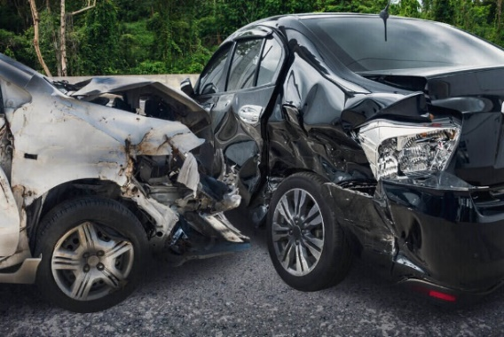 Motorization of the population is growing quickly. In these nations, where the rate of road traffic accidents is 94 percent of all registered vehicles worldwide are motorised. An outcome of a road traffic accident is interplay between several factors, such as the surroundings, the car, and the person. Typically, it is thought to be an accident that is unforeseeable when it comes to road traffic inevitable. However, the majority of the time, traffic accidents can be predicted and avoided. Understanding the causes and contributing elements of traffic accidents is necessary for this.

**Fig.1.1 Road Traffic Accident**

**1.2. Reasons for Road Traffic Accidents:**

**Factors affecting risk exposure:**

A person's exposure to the risk of a traffic accident can be influenced by their mode of transportation, average travel time, length of trip, and the layout and construction of the road as well as their knowledge of traffic laws and road signs.

**Human Factors in RTA:**

Carelessness on the part of drivers results in traffic accidents. Human variables in RTA include things like drunk driving, excessive speeding, and disregard for the law. Some of the causes of traffic accidents on the roads are careless driving. driver negligence. drowsiness, failure to use safety belts and helmets, and medical issues such as acute illness, myocardial infarction, and eyesight impairment. Risk-taking, impulsivity, and distracted driving caused by using a phone while driving are all psychological characteristics that contribute to accidents.

**Environmental risk factors:**

These are connected to the roadways, such as bad and narrow roads, bad crossroads design. inadequate lighting and unfamiliarity poor design, construction, etc. The hiring of contractors to build roads is another element. Some of the contractors have a strong focus on profit, which leads to roads of poor quality. Road divots and potholes are factors in traffic accidents.

**Vehicles factors:**

Road traffic accidents are significantly influenced by the state of the automobiles on the roads. A few factors related to automobiles include excessive speed, badly maintained vehicles, a high volume of vehicles, poor driving standards, and overcrowded buses.

**1.3 Preventive Measures:**

It is possible to avoid a lot of traffic fatalities. Preventive measures include, among others:

**Vehicles:**

Accidents can be decreased by using vehicles with good brakes, lighting, tyres, and other components. Vehicles that are heavily polluting and that have been in operation for a very long time should be phased out. Make sure all vehicles have seatbelts and other important safety features, such as airbags.

**Condition of roads or Environmental conditions:**

Roads must be maintained on a regular basis, including regular resurfacing and marking of road safety signs. Road accidents may be decreased by providing appropriate walkways for pedestrians and pedestrian crossings at crossroads. There should be two separate lanes for fast and slow driving automobiles. To provide good visibility, roadways and intersections should be wide and well-lit.

**Human factors:**

The main contributors to the decline in traffic accidents are the drivers. The issuance of driving licences should only be based on the minimal proficiency attained by students from approved driving schools. All drivers ought to have received the appropriate instruction and have a current licence. It is important to spread awareness about traffic laws among drivers. The health of drivers should be periodically checked, especially their vision and hearing. The penalty for breaking traffic laws should be strengthened. There should be rigorous overloading checks. RTA can be decreased by requiring the mandatory registration of criminal offences involving overloading. Everyone should wear road safety equipment including belts, helmets, and other useful items. The permits should be cancelled as a result of the vehicles transporting more passengers. A national accident relief policy is required to guarantee quick assistance. free trauma care, paramedic, teacher, and other professionals' training, Strict regulations should be put in place to make seat belts and helmets for two-wheelers mandatory. The relevant authorities must strictly enforce the traffic laws. Traffic will move more smoothly if encroachments on footpath borders are removed. Traffic will move freely if random vehicle puking is avoided on congested roads and crossings.

**Management of accident victims:**

The community and other drivers should be made aware of the importance of providing the accident victim with sufficient care in order to save the injured. Along with providing ambulances and skilled medical personnel to relocate and transport the injured person to local hospitals for treatment, highways and busy roadways should also have medical care facilities available. By raising awareness throughout the community about how accident victims should be treated with compassion and without fear, morbidity and mortality can be decreased.

**CHAPTER 2**

**Objectives**

* Using sensors to detect the vehicles at the curve effectively.
* To alert the driver of the vehicle on the road side of the curve.
* To enable the system to be handled automatically.

**CHAPTER 3**

**METHODOLOGY**

**3.1. Working:**

UV sensors, LED lights, and buzzers are all part of the system, which is situated on the side of the road. The buzzers sound when any vehicle drives over the UV sensors. On either side of the hairpin curve, there are two UV sensors that are used. When a vehicle passes in front of the sensor on one side of a curve, the sensor immediately informs the driver of the car on the opposite side of the curve by lighting up a red LED and beeping a buzzer. LEDs are used to identify the position of vehicles on either side of the bend based on sensor output. For certain scenarios, the appropriate LED is triggered, prioritising the movement of the vehicles.

LED GLOW

ADRUINO UNO

ULTRASONIC

SENSOR

LCD DISPLAY

BUZZER

**Fig.3.1.Block diagram of Proposed System**

**3.2.Implementation of Circuit**

As the position of the vehicle and the width of the road play a major role in this system, the appropriate sensors are chosen for integration into the circuit. All necessary components are connected to and logical operations are carried out using an Arduino UNO board. The elements of the circuit are selected

**ARDUINO UNO**

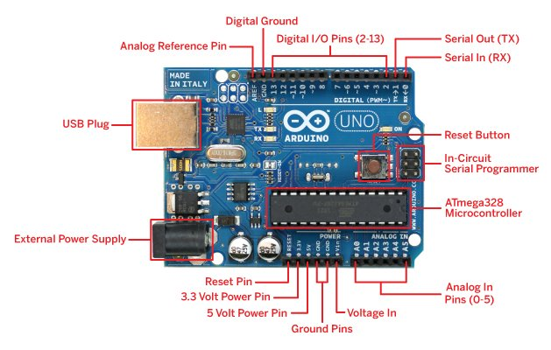

Fig 3.2.1 ARDUINO UNO Board

|  |  |
| --- | --- |
| Microcontroller | At mega 328 |
| Clock speed | 16MHz |
| Operating Voltage | 5 volts |
| Supply Voltage | 7-12 volts |
| Analog Input Pins | 6 |
| Digital Input/Output Pins | 14 |
| DC Current per input/output pin | 40 mA |
| SRAM | 2 kB |
| EEPROM | 1 kB |
| Flash Memory | 32 kB |

Table 3.2.1.Specifications of Arduino UNO

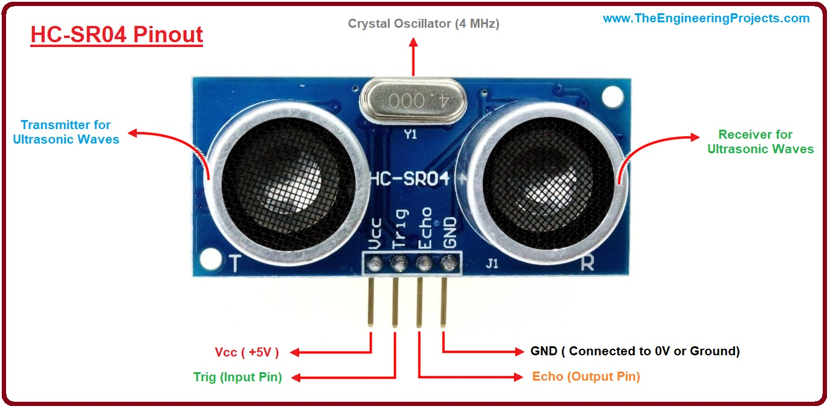**Ultrasonic module:**

**Fig.3.2.2.HC-SR04 Ultrasonic Module**

|  |  |
| --- | --- |
| Operating voltage | 5 V DC |
| Operating Current | 15 mA |
| Operating Frequency | 40 kHz |
| Farthest Range | 4 m |
| Nearest Range | 2 m |
| Measuring Angle | 15 Degrees |
| Input Trigger Signal | 10 us TTL Pulse |
| Output Trigger Signal | Proportional with range |

**Table 3.2.2. Specifications of Ultrasonic module**

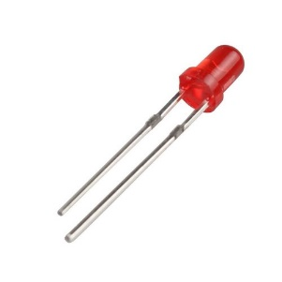**RED LED:**

|  |  |
| --- | --- |
| Voltage | 1.8-2.4 V |
| Current | 80 mA |
| Wavelength | 620-630 nm |
| Power | 0.3 W |

**Table 3.2.3.Specifications of RED LED Fig 3.2.3.RED LED**

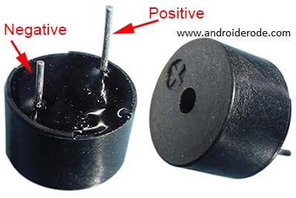**BUZZER**

|  |  |
| --- | --- |
| Operating voltage | 3.0-18.0 V DC |
| Temperature range | -20 to +40 Degrees |
| Sound Level | 85 dB |
| Resonant frequency | 3-15 kHz |

**Table 3.2.4.Buzzer specifications Fig 3.2.4.Buzzer**

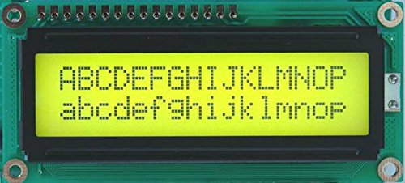**16x2 LCD Display:**

|  |  |
| --- | --- |
| Operating voltage | 4.7-5.3 V |
| Dezel | 72x25 mm |
| Operating Current | 1 mA |
| PCB Size of the Module | 80Lx36Wx10H mm |
| LED Colour | Green or Blue |

**Table 3.2.5.16x2 LCD Display**

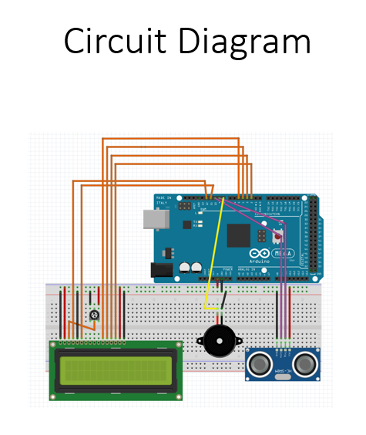

**CONNECTIONS**

The HC-SR04 Ultrasonic Module has 4 pins, Ground, VCC, Trig and Echo. The Ground and the VCC pins of the module should be connected to the Ground and the 5 volts pins on the Arduino Board respectively and the trig and echo pins to any Digital 1/0 pin on the Arduino Board.

* The HC-SR04 sensor attaches to the breadboard.
* The Sensor VCC is connected to the Arduino Board +5V.
* The Sensor GND is connected to the Arduino Board GND.
* The Sensor Trig is connected to the Arduino Board Digital 1/O 9.
* The Sensor Echo is connected to the Arduino Board Digital 1/0 10.

**Buzzer and LED**

* The buzzer is attached to the breadhoard.
* The buzzer long leg (+) is connected to the Arduino Bond Digital 11.
* The Buzzer short leg (-) is connected to the Arduino Board GND,
* The LED is attached to the breadboard.
* The resistor is connected to the LED long leg (4) and other leg is connected to the Arduino Board Digital 13
* The LED short leg (-) connect to the Arduino Board GND.

**LCD Display:**

* One side of the Potentiometer is connected to the +ve line of the breadboard
* Another side of the Potentiometer is connected to the –ve line of the breadboard
* The 1st and 16 pins of LCD are connected to the –ve line of the breadboard
* The 2nd and 15 pins of LCD(provide power to the display)are connected to the +ve line of the breadboard
* The 5th pin of the LCD is connected to the ground
* The 3rd pin of the LCD(control the contrast) is connected to the centre pin of the Potentiometer
* The 4th pin(register select pin we out to from Arduino UNO)is connected to the 12 pins of the Arduino UNO
* The 6th pin of the LCD is connected to the 11 pins of the Arduino UNO
* The 11th, 12th,13th, and 14th pins of the LCD are connected to the 5th,4th,3rd, and 2nd respectively of the pins of the Arduino UNO

**3.3.Implementation of Code and Testing**

include <LiquidCrystal.h>

const int trig_pin = 9;

const int echo_pin = 10;

const int buzzer_pin = 11;

const int ledPin = 13;

int distance_cm;

long duration;

const int rs = 12, en = 6, d4 = 5, d5 = 4, d6 = 3, d7 = 2;

LiquidCrystal lcd(rs, en, d4, d5, d6, d7);

void setup()

{

lcd.begin(16, 2);

lcd.setCursor(0, 0);

pinMode(trig_pin, OUTPUT);

pinMode(echo_pin, INPUT);

pinMode(buzzer_pin, OUTPUT);

pinMode(ledPin, OUTPUT);

Serial.begin(115200); // Starts the serial communication

}

void loop()

{ digitalWrite(trig_pin, LOW);

delayMicroseconds(2);

digitalWrite(trig_pin, HIGH);

delayMicroseconds(10);

digitalWrite(trig_pin, LOW);

duration = pulseIn(echo_pin, HIGH);

distance_cm = (duration*0.034)/2.0;

if (distance_cm >= 20 || distance_cm <= 0)

{

digitalWrite(buzzer_pin, LOW);

digitalWrite(ledPin, LOW);

lcd.setCursor(0, 0);

lcd.print("NO OBJECT[>20cm]");

Serial.print("NO OBJECT[>20cm]");

lcd.setCursor(0, 1);

lcd.print("OBJECT DETECTED!");

Serial.print("OBJECT DETECTED");

delay(1000);

lcd.clear();

}

else

{

digitalWrite(buzzer_pin, HIGH);

digitalWrite(ledPin, HIGH);

lcd.setCursor(0, 0);

lcd.print("DISTANCE(cm):");

lcd.print(distance_cm);

Serial.print("DISTANCE(cm):");

Serial.println(distance_cm);

lcd.setCursor(0, 1);

lcd.print("OBJECT DETECTED!");

Serial.print("OBJECT DETECTED!");

delay(1000);

lcd.clear();

}

// Prints the distance on the Serial Monitor

Serial.print("Distance: ");

Serial.println(distance_cm);

}

**Results and Discussions**

The circuit is implemented using ultrasonic module, buzzer,LED and LCD Display. The circuit is checked by implementing it on the prototype and verified for different positions of the vehicles at the curve

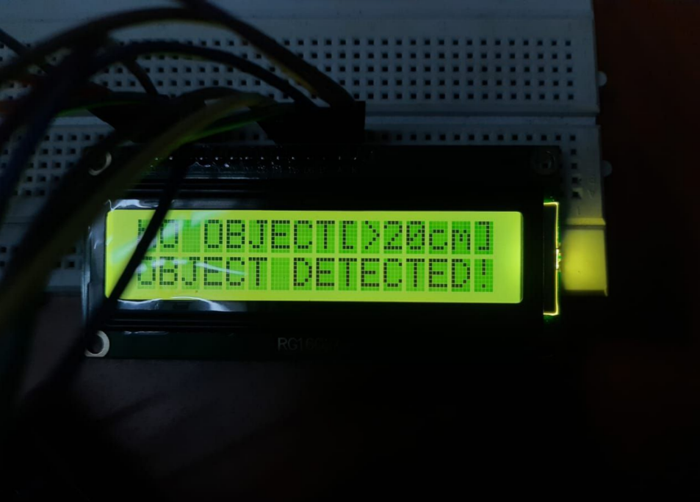**Case 1:No Object detected**

**Case 2: Object Detected:**

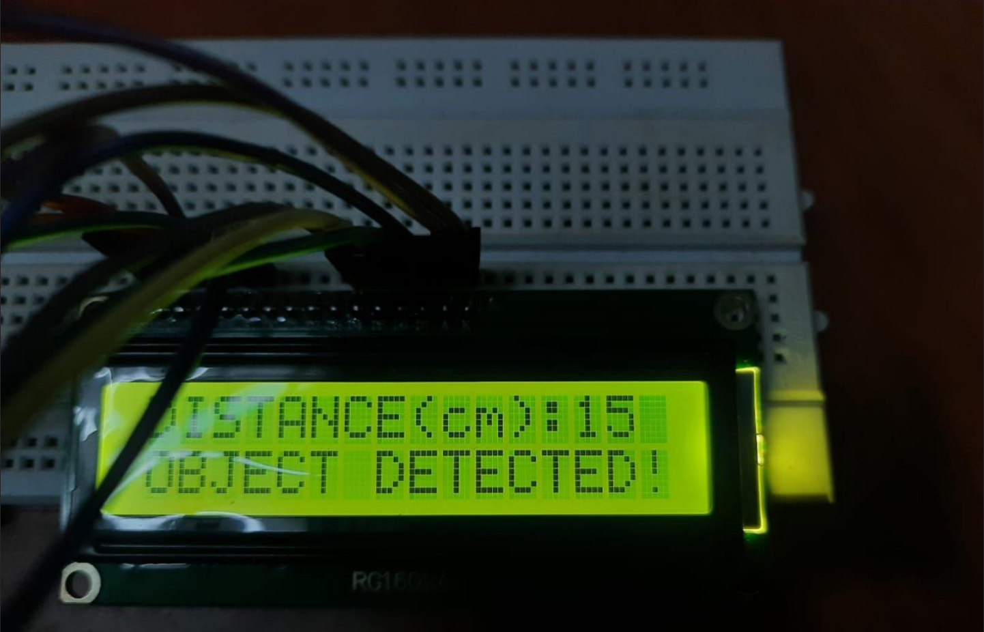

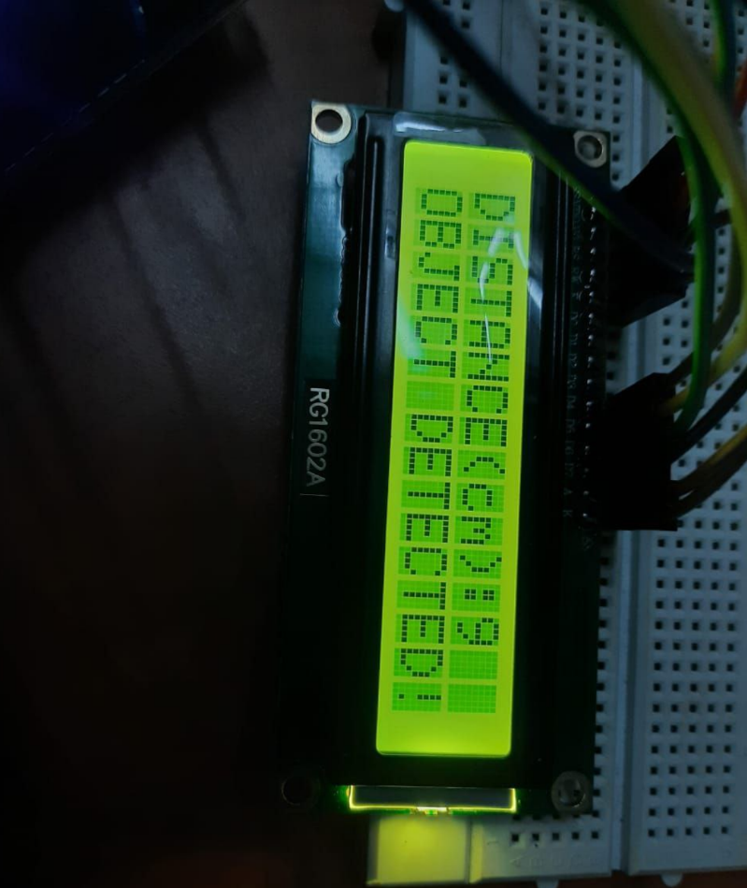

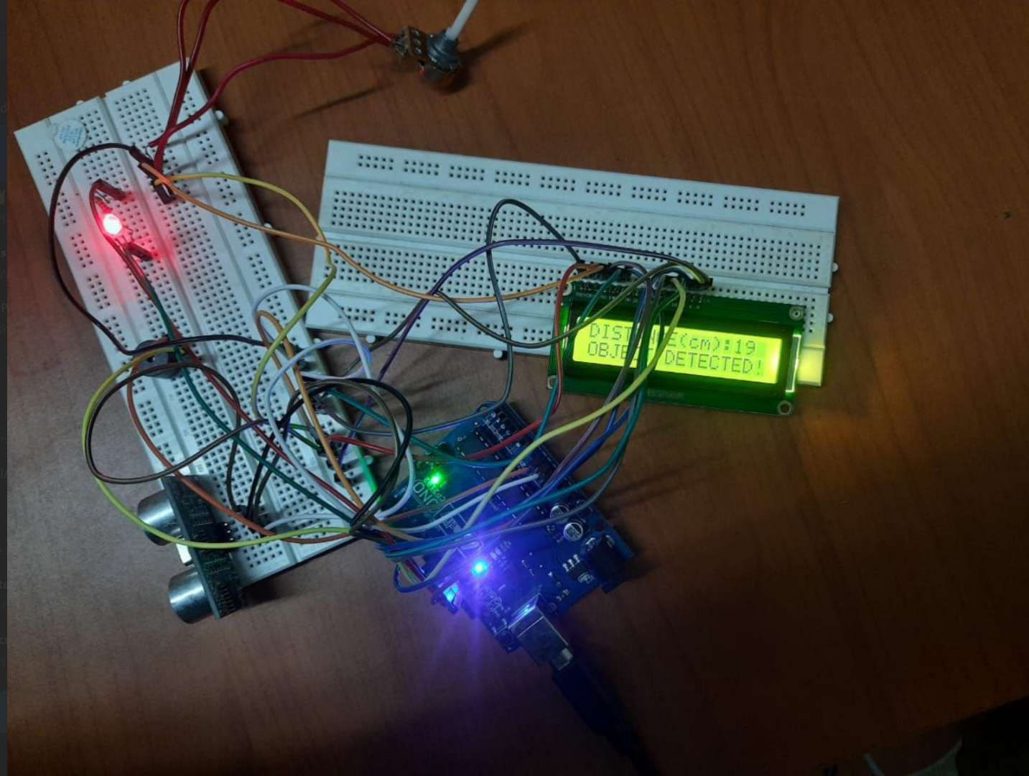**Overview of the Circuit:**

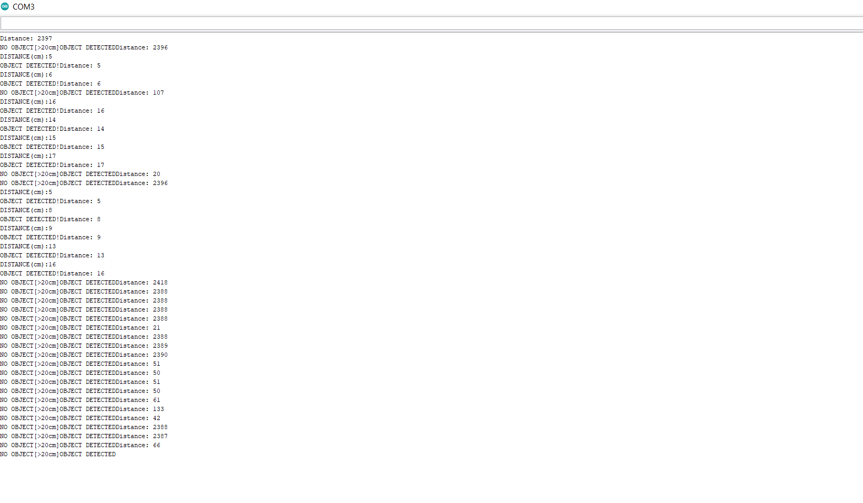**Observation:**

|  |  |  |  |
| --- | --- | --- | --- |
| **Position of Obstacle** | **Status of LED** | **Status of Buzzer** | **LCD Display** |
| 1.Beyond the sensor | OFF | OFF | ‘’NO OBJECT DETECTED” |
| 2.At the sensor | ON | ON | “OBJECT DETECTED” |
| 3.Ahead the sensor | OFF | OFF | “NO OBJECT DETECTED” |

**Table.4.1. Outcomes of the experiment**

**CHAPTER 5**

**Conclusions and Future Scope**

A prototype for a successful system to prevent traffic accidents was put into action. The Arduino UNO processor was programmed to recognise the car and warn the driver of the car around the corner. As a replacement for the current convex lens approach utilised at curving roadways to reduce accidents, it is also an automation system.

It can work in various climatic circumstances and reduce the amount of labour needed to maintain the convex lens.

Even if a system failure results in an accident, the GSM Module can still be used to expand the system's ability to provide assistance to the injured as quickly as possible. This would notify surrounding hospitals or anyone connected to the victim that an accident has occurred. The hospital will dispatch an ambulance to the place where the communication was received as soon as it is received. Consequently, it may enable someone to live.

**References:**

* Wei-Chung Hsieh, L. -C. Fu and Shin-Shinh Huang, "Vision based obstacle warning system for on-road driving," *Proceedings 2003 IEEE/RSJ International Conference on Intelligent Robots and Systems (IROS 2003) (Cat. No.03CH37453)*, 2003, pp. 3668-3673 vol.3, doi: 10.1109/IROS.2003.1249725.
* U. Khalil, A. Nasir, S. M. Khan, T. Javid, S. A. Raza and A. Siddiqui, "Automatic Road Accident Detection Using Ultrasonic Sensor," *2018 IEEE 21st International Multi-Topic Conference (INMIC)*, 2018, pp. 206-212, doi: 10.1109/INMIC.2018.8595541.
* R.Palanisamy1 , PLS Sai Kumar2 , Mekala Paavan Kiran3 , Ashutosh Mahto4 , Md.Irfan5 , ” ARDUINO based accident prevention and auto intimation system,” Indonesian Journal of Electrical Engineering and Computer Science Vol. 17, No. 3, March 2020, pp. 1275~1280 ISSN: 2502-4752, DOI: 10.11591/ijeecs.v17.i3.pp1275-128
* Demo Video: <https://youtu.be/P1EBlulrAOo>